Assignmnet:- 2

Ques 1

WAP to find the element by linear search

Code:-

**package** array;

**import** java.util.Scanner;

**public** **class** Search {

**public** **static** **void** main(String[] args) {

Scanner s=**new** Scanner(System.***in***);

**int** n;

System.***out***.println("Enter the no of element");

n=s.nextInt();

**int** num[]=**new** **int**[n];

System.***out***.println("Enter the Elements ");

**for**(**int** i=0;i<n;i++)

{

num[i]=s.nextInt();

}

**int** ele;

System.***out***.println("Enter the element u search ");

ele=s.nextInt();

**int** co=0;

**for**(**int** i=0;i<n;i++)

{

**if**(num[i]==ele)

{

co=co+1;

}

}

**if**(co>0)

System.***out***.println("Found");

**else**

System.***out***.println("Not Found");

}

}

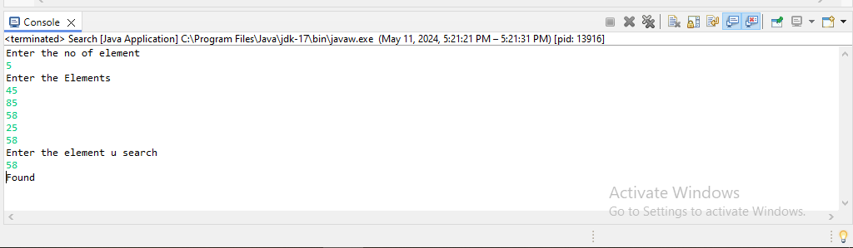

Ques 2

WAP to sorting the array element using following algorithm Bubble sort  
Code:-

**package** assignment2;

**import** java.util.Scanner;

**public** **class** BubbleSort {

**public** **static** **void** main(String[] args) {

Scanner s=**new** Scanner(System.***in***);

System.***out***.println("Enter the no of element u want");

**int** n;

n=s.nextInt();

**int** num[]=**new** **int**[n];

System.***out***.println("Enter the element");

**for**(**int** i=0;i<n;i++)

{

num[i]=s.nextInt();

}

System.***out***.println("Unsorted Array");

**for**(**int** i=0;i<n;i++)

{

System.***out***.print(num[i]+" ");

}

**int** temp=0;

**for**(**int** i=0;i<n-1;i++)

{

**for**(**int** j=i+1;j<n;j++)

{

**if**(num[i]>num[j])

{

temp=num[i];

num[i]=num[j];

num[j]=temp;

}

}

}

System.***out***.println("");

System.***out***.println("Sorted array ");

**for**(**int** i=0;i<n;i++)

{

System.***out***.print(num[i]+" ");

}

}

}

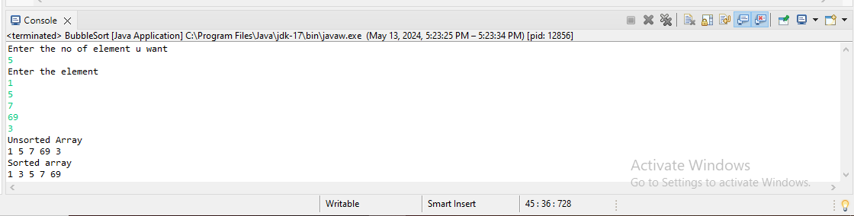

Ques 3

WAP to sorting the array element using following algorithm Selection sort

Code:-

**package** assignment2;

**import** java.util.Scanner;

**public** **class** Selectionsort {

**public** **static** **void** main(String[] args) {

Scanner s=**new** Scanner(System.***in***);

System.***out***.println("Enter the no of element u want");

**int** n;

n=s.nextInt();

**int** num[]=**new** **int**[n];

System.***out***.println("Enter the element");

**for**(**int** i=0;i<n;i++)

{

num[i]=s.nextInt();

}

System.***out***.println("Unsorted Array");

**for**(**int** i=0;i<n;i++)

{

System.***out***.print(num[i]+" ");

}

**int** temp=0,k=0;

**for**(**int** i=0;i<n;i++)

{

**int** max=num[i];

**for**(**int** j=i;j<n;j++)

{

**if**(num[j]<max)

{

k=j;

max=num[j];

}

}

temp=num[i];

num[i]=num[k];

num[k]=temp;

}

System.***out***.println("sorted Array");

**for**(**int** i=0;i<n;i++)

{

System.***out***.print(num[i]+" ");

}

}

}

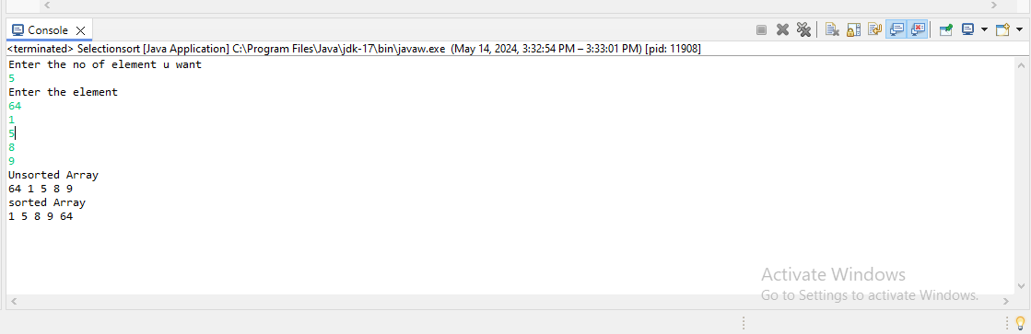

Ques 4

WAP to print multiplication table within the range if range is R1=7 and R2=12

Code:-

**package** array;

**import** java.util.Scanner;

**public** **class** Table {

**public** **static** **void** main(String[] args) {

**int** n;

Scanner s=**new** Scanner(System.***in***);

System.***out***.println("Enter the no is u want table");

n=s.nextInt();

**if**(n>=7 && n<=12)

{

**for**(**int** i=1;i<=10;i++)

{

System.***out***.println(n+" X "+i+" = "+(n*i));

}

}

**else**

System.***out***.println("Out of range ");

}

}

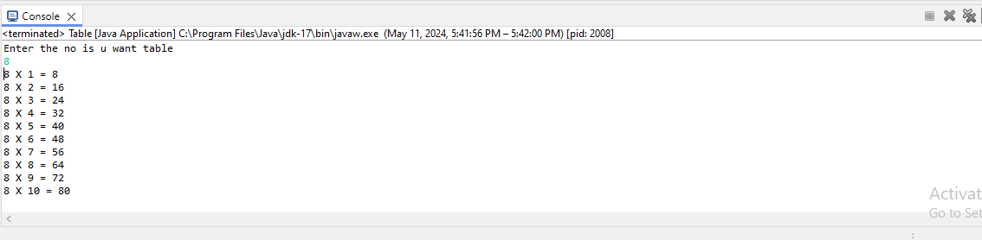

Ques 5

WAP to display matrix multiplication

Code:-

**package** assignment2;

**import** java.util.Scanner;

**public** **class** mulmatrics {

**public** **static** **void** main(String[] args) {

Scanner s=**new** Scanner(System.***in***);

**int** n,m,n1,m1;

System.***out***.println("Enter the index of row of first maxtrix ");

n=s.nextInt();

System.***out***.println("Enter the index of column of first matrix");

m=s.nextInt();

System.***out***.println("Enter the index of row of Second maxtrix ");

n1=s.nextInt();

System.***out***.println("Enter the index of column of second matrix");

m1=s.nextInt();

**if**(m!=n1)

{

System.***out***.println("Maxtix multiplication not possible");

}

**else**

{

**int** arr[][]=**new** **int**[n][m];

**int**[][] arr1=**new** **int**[n1][m1]; //2d array representation

System.***out***.println("Enter the matrix first value ");

**for**(**int** i=0;i<n;i++)

{

**for**(**int** j=0;j<m;j++)

{

arr[i][j]=s.nextInt();

}

}

System.***out***.println("Enter the matrix Second value ");

**for**(**int** i=0;i<n;i++)

{

**for**(**int** j=0;j<m;j++)

{

arr1[i][j]=s.nextInt();

}

}

**int**[][] c=**new** **int**[n][m1];

**for**(**int** i=0;i<n;i++)

{

**for**(**int** j=0;j<m1;j++)

{

c[i][j]=0;

**for**(**int** k=0;k<m1;k++)

{

c[i][j]=c[i][j]+(arr[i][k]*arr1[k][j]);

}

}

}

System.***out***.println("New maxtrix :");

**for**(**int** i=0;i<n;i++)

{

**for**(**int** j=0;j<m;j++)

{

System.***out***.print(c[i][j]+" ");

}

System.***out***.println("");

}

}

}

}

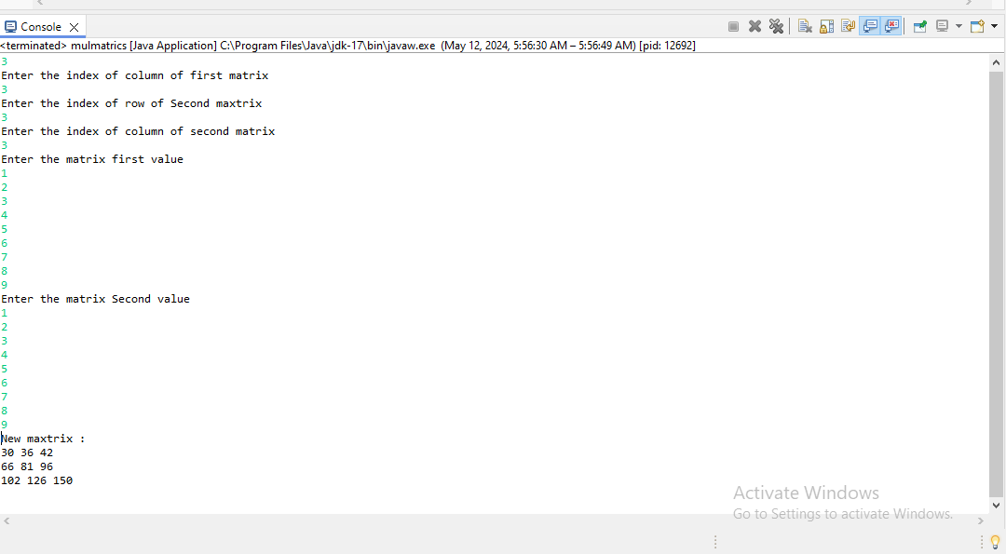

Ques 6

WAP to ask a name from user and check if that name exist in an array or not.

Code:-

**package** assignment2;

**import** java.util.Scanner;

**public** **class** Linearser {

**public** **static** **void** main(String[] args) {

Scanner s=**new** Scanner(System.***in***);

System.***out***.println("Enter the no of element u want insert");

**int** n;

n=s.nextInt();

s.nextLine();

String num[]=**new** String[n];

System.***out***.println("Enter the Elements ");

**for**(**int** i=0;i<n;i++)

{

num[i]=s.nextLine();

}

String sname;

System.***out***.println("Enter the name u found");

sname=s.next();

**int** k=0;

**for**(**int** i=0;i<n;i++)

{

**if**(num[i].equals(sname))

{

k=k+1;

**break**;

}

}

**if**(k==1)

System.***out***.println("Found");

**else**

System.***out***.println("Not Found");

}

}

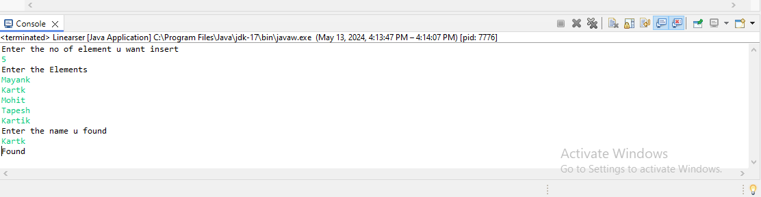

Ques 7

what will be the output of the following program when it is executed with the command line argument?  
Java contest how are you  
Class contest  
{  
public void main(String args[])  
{  
System.out.println (args [1]);  
}  
}

Code:-

**package** assignment2;

**public** **class** Ques_7 {

**public** **static** **void** main(String[] args) {

System.***out***.println(args[1]);

}

}

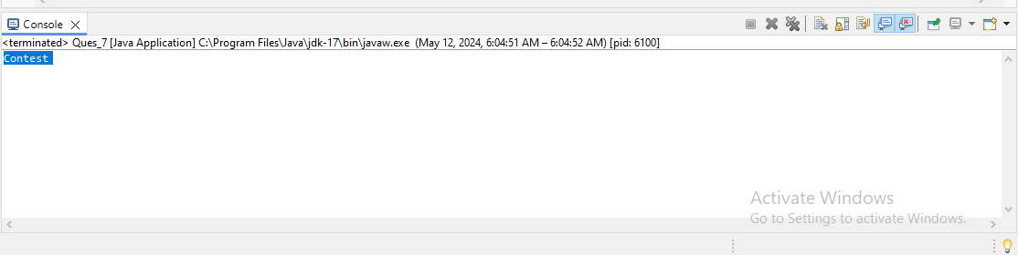

Ques 8

Write a program that accept string as command line argument and generate the output in specific way Example twotwo command line argument are wipro and bangolre then the ouput generated should be wipro technology banglore   
If the argument are ABC and Mumbai then output should be ABC technology Mumbai

Code:-

**package** array;

**public** **class** Commandline2 {

**public** **static** **void** main(String[] args) {

System.***out***.println(args[0]+" Technology "+args[1]);

}

}

